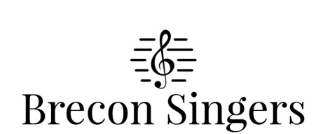
Charity Gift Aid Declaration
Boost your donation by 25p of Gift Aid for every £1 you donate
Gift Aid is reclaimed by the charity from the tax you pay for this current tax year. Your address is needed to identify you as a current UK taxpayer.

In order to Gift Aid your donation you must tick the box below:
I want to Gift Aid my donation of £___________________ and any donations I make in the future or
have made in the past 4 years to Brecon Singers, Registered Charity No. 519070.

I am a UK tax payer and understand that if I pay less Income Tax and/or Capital Gains Tax in the current tax year than the amount of Gift Aid claimed on all my donations in that tax year it is my responsibility to pay any difference.

My Details
Title__________________________________First Name or Initial(s)_______________________________________
Surname _______________________________________________________________________________
Full Home Address _______________________________________________________________________
_______________________________________________________________________________________
______________________________________________Postcode__________________________________

Signature _____________________________________Date ______________________________________
Please notify the charity if you:
- want to cancel this declaration
- change your name or home address
- no longer pay sufficient tax on your income and/or capital gains.

If you pay Income Tax at the higher or additional rate and want to receive the additional tax relief due to you, you must include all your Gift Aid donations on your Self-Assessment tax return or ask HM Revenue and Customs to adjust your tax code.

